Portfolio Optimization and Performance Evaluation using Modern Portfolio Theory (MPT)

Introduction
Modern Portfolio Theory (MPT), introduced by Harry Markowitz (1952), remains one of the foundational frameworks for constructing investment portfolios that balance expected return and risk through diversification. Rather than selecting securities solely on the basis of expected returns, MPT emphasises combining assets whose returns are imperfectly correlated to improve the portfolio's overall risk-return profile.
This project evaluates the application of Modern Portfolio Theory to a portfolio of four Indian blue-chip companies—HDFC Bank, Infosys, Reliance Industries and Hindustan Unilever (HUL)—over the period January 2019 to December 2025. The study investigates whether optimized portfolios constructed using Monte Carlo simulation and constrained optimization outperform a naïve Equal-Weighted Portfolio (EWPF) and the NIFTY 50 benchmark on a risk-adjusted basis.
The analysis progresses systematically from exploratory data analysis to portfolio optimization and finally to performance evaluation using both traditional and downside risk measures.

Objectives
- To analyse the historical performance of selected Indian equities.
- To construct an Equal-Weighted Portfolio as a baseline.
- To generate portfolios using Monte Carlo simulation.
- To obtain mathematically optimal portfolios through constrained optimization.
- To evaluate portfolio performance using risk-adjusted measures.
- To compare portfolio strategies with the NIFTY 50 benchmark.

Methodology
The study follows a structured workflow illustrated below:

Historical daily adjusted closing prices were downloaded from Yahoo Finance using the yfinance package. Daily returns were computed after validating the dataset for missing values and ensuring chronological consistency.
An Equal-Weighted Portfolio was first constructed to provide a simple diversification benchmark. Portfolio optimization was then performed using two complementary approaches:
- Monte Carlo simulation (10,000 portfolios) to explore the feasible investment opportunity set.
- Sequential Least Squares Programming (SLSQP) to obtain mathematically optimal Maximum Sharpe and Minimum Variance portfolios under realistic investment constraints:
  - Portfolio weights sum to one.
  - No short selling.
  - Portfolio weights bounded between 0 and 1.
Portfolio performance was evaluated using:
- Annualized Return
- Annualized Volatility
- Sharpe Ratio
- Maximum Drawdown
- Calmar Ratio
Finally, all portfolios were benchmarked against the NIFTY 50 Index.

Exploratory Data Analysis
The normalized price chart indicates substantial differences in the long-term performance of the four stocks. Reliance Industries and Infosys exhibited the strongest cumulative appreciation during the study period, whereas HDFC Bank and Hindustan Unilever experienced comparatively slower growth.
The correlation matrix revealed moderate positive correlations among the selected stocks, ranging approximately between 0.25 and 0.42. Since none of the assets moved perfectly together, combining them offered meaningful diversification opportunities, consistent with the principles of Modern Portfolio Theory.
Individual stock performance further demonstrated that Reliance achieved the highest Sharpe Ratio (0.434), followed closely by Infosys (0.397), indicating superior historical risk-adjusted performance. Infosys recorded a negative Sharpe Ratio because its annualized return remained below the assumed 6% risk-free rate.
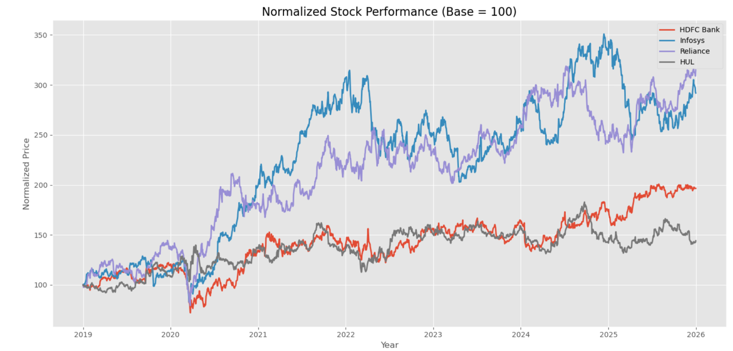
Figure 1: Normalised Stock Prices

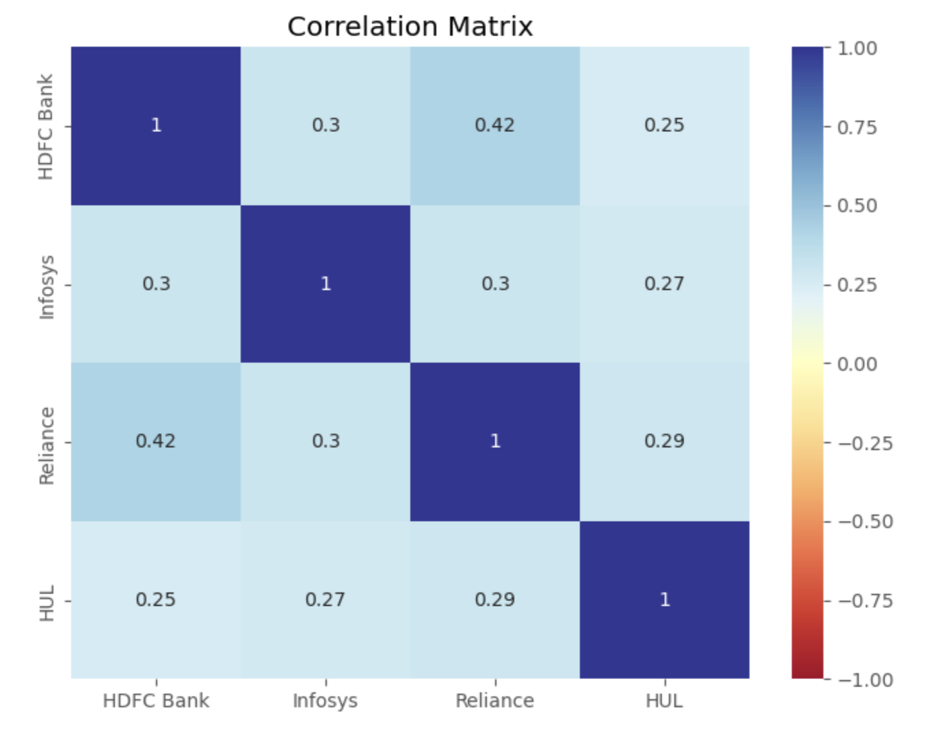
Figure 2: Correlation Heatmap

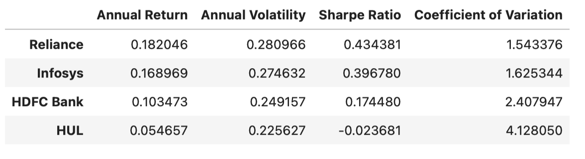
Table 1: Risk-Return Performance of Individual Stocks

Portfolio Construction and Optimization
The Equal-Weighted Portfolio allocated 25% of capital to each stock and served as the baseline strategy against which optimization techniques were evaluated.
Monte Carlo simulation generated 10,000 randomly weighted portfolios, allowing visualization of the feasible risk-return opportunity set. Each portfolio was evaluated using annualized return, volatility and the Sharpe Ratio. The simulation identified portfolios with the highest Sharpe Ratio and the lowest variance.
To obtain mathematically optimal solutions, constrained optimization was subsequently performed using the SLSQP algorithm. Unlike Monte Carlo simulation, which relies on random sampling, SLSQP directly solves the optimization problem while satisfying practical investment constraints.
The optimized Maximum Sharpe portfolio allocated nearly all capital between Reliance Industries and Infosys, reflecting their superior historical risk-adjusted performance. Conversely, the Minimum Variance portfolio assigned a larger allocation to Hindustan Unilever because optimization sought to minimize overall portfolio volatility rather than maximize individual stock returns.
The close agreement between Monte Carlo portfolios and their mathematically optimized counterparts indicates that the random simulation successfully approximated the optimal region of the feasible investment set.
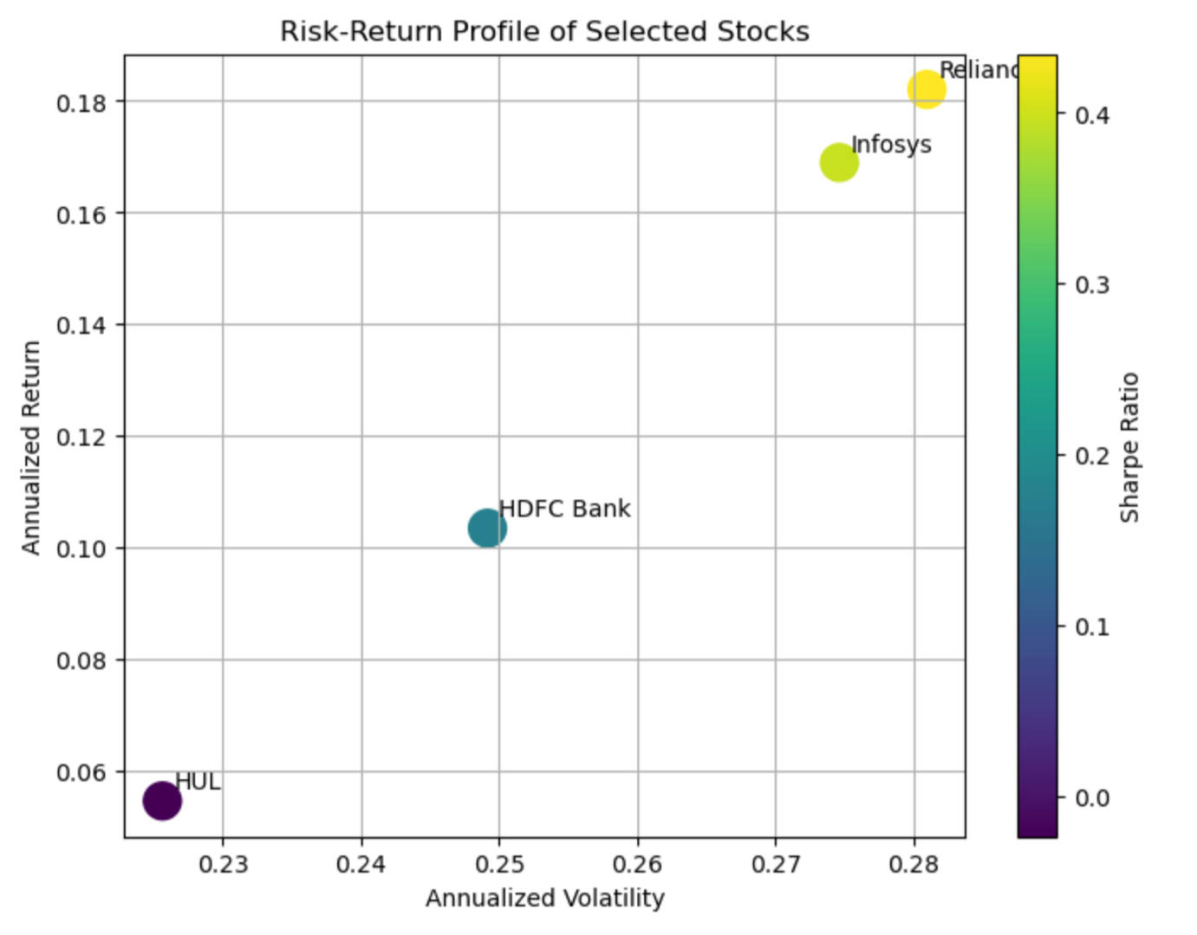
Figure 3: Risk-Return on Individual Stocks

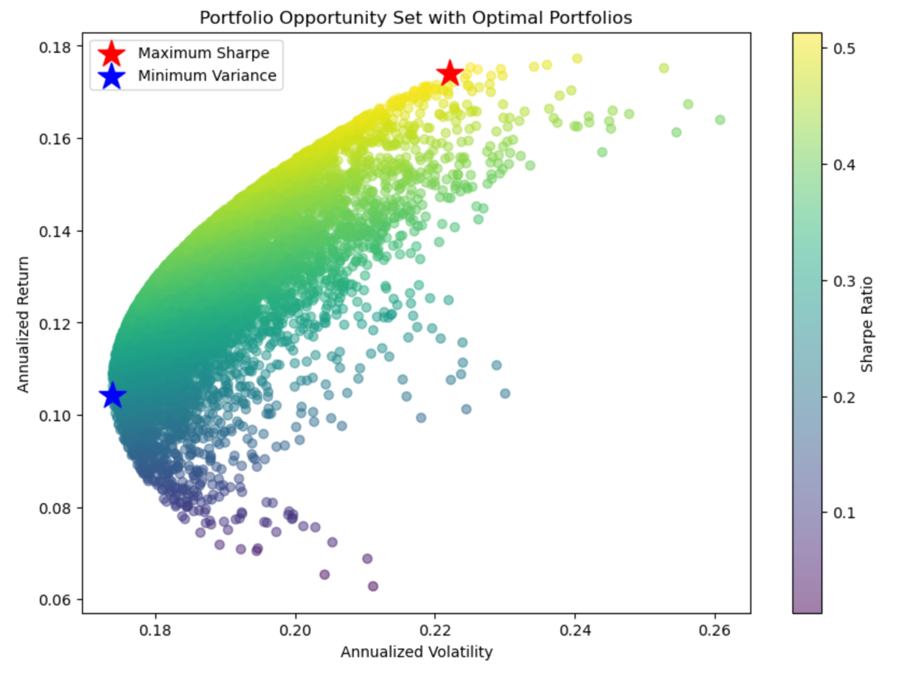
Figure 4: Efficient Frontier using Monte Carlo Simulation

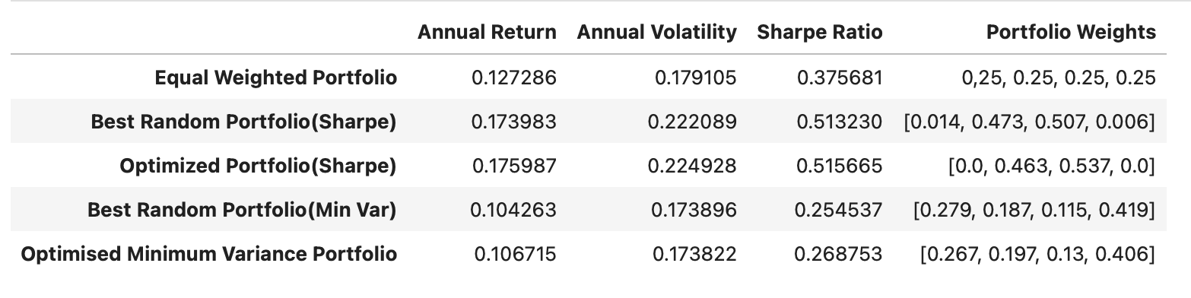
Table 2: Portfolio Weights

Performance Evaluation and Benchmark Comparison
The optimized Maximum Sharpe portfolio achieved the highest annualized return (17.6%) and the strongest risk-adjusted performance, with a Sharpe Ratio of approximately 0.52. The Minimum Variance portfolio exhibited the lowest annualized volatility (17.4%), although this reduction in risk came at the cost of lower returns.
Downside risk analysis complemented these findings. Maximum Drawdown quantified the largest historical loss experienced by each portfolio, while the Calmar Ratio evaluated return relative to that worst decline. Together with the Sharpe Ratio, these measures provided a comprehensive assessment of portfolio quality from both total-risk and downside-risk perspectives.
Benchmark comparison demonstrated that the optimized portfolios generally outperformed the NIFTY 50 on a risk-adjusted basis during the historical sample period. However, these findings should be interpreted as evidence of superior historical performance rather than a guarantee of future outperformance.
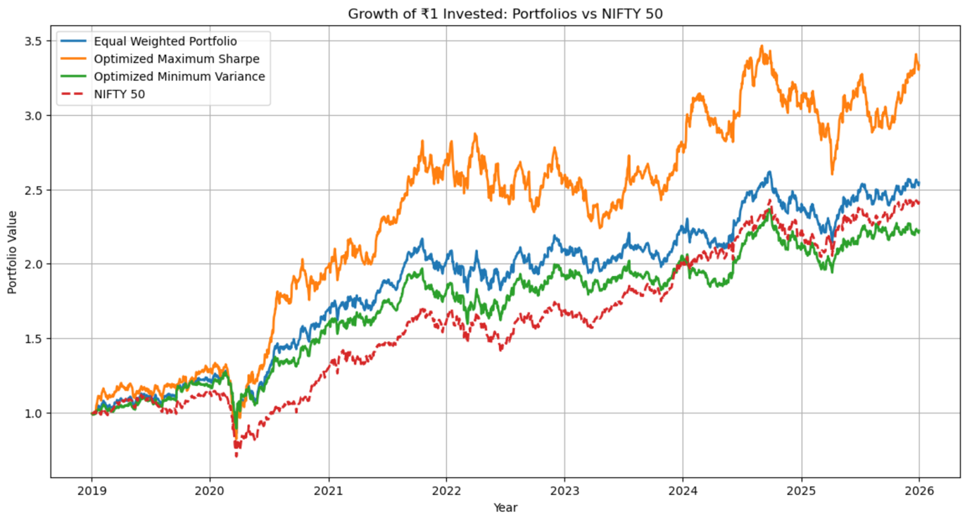
Figure 5: Growth of ₹1 Invested in Portfolios vs Nifty 50

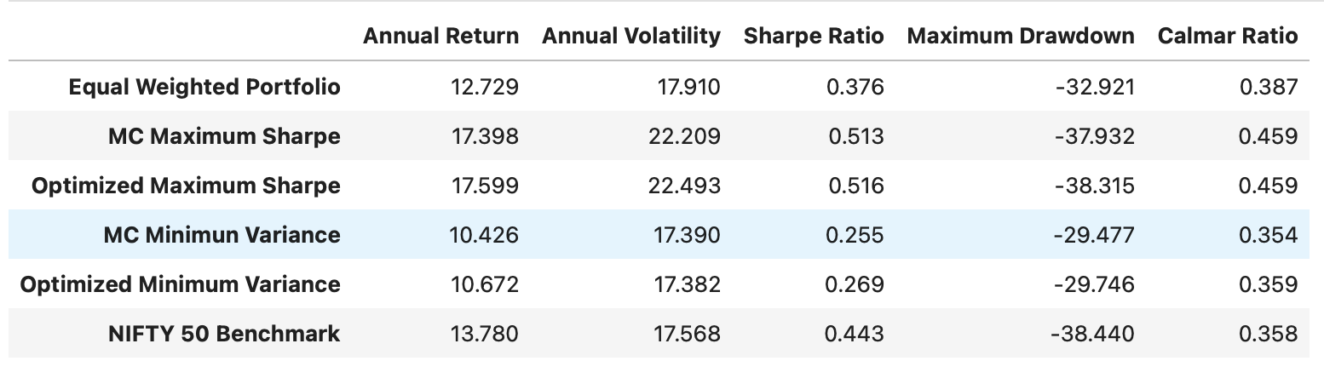
Table 3: Final Performance Comparison

Conclusion
This study demonstrates the practical application of Modern Portfolio Theory to portfolio construction using Indian equity data between 2019 and 2025. By combining Monte Carlo simulation with constrained numerical optimization, the analysis identified portfolios that exhibited stronger historical risk-adjusted performance than a simple Equal-Weighted Portfolio.
The inclusion of Maximum Drawdown and the Calmar Ratio extended the evaluation beyond traditional volatility-based measures, providing a more comprehensive assessment of downside risk. Benchmarking against the NIFTY 50 further placed the optimized portfolios within a realistic investment context.
While the optimized portfolios outperformed the benchmark during the study period, the results remain conditional upon historical market conditions. Future research may extend the analysis through rolling-window optimization, out-of-sample backtesting, larger investment universes, and advanced risk measures such as Value at Risk (VaR) and Conditional Value at Risk (CVaR).

